ATCHE – Electrolytic Cells

Difference between a galvanic (voltaic/battery) and electrolytic (electrolysis) cell

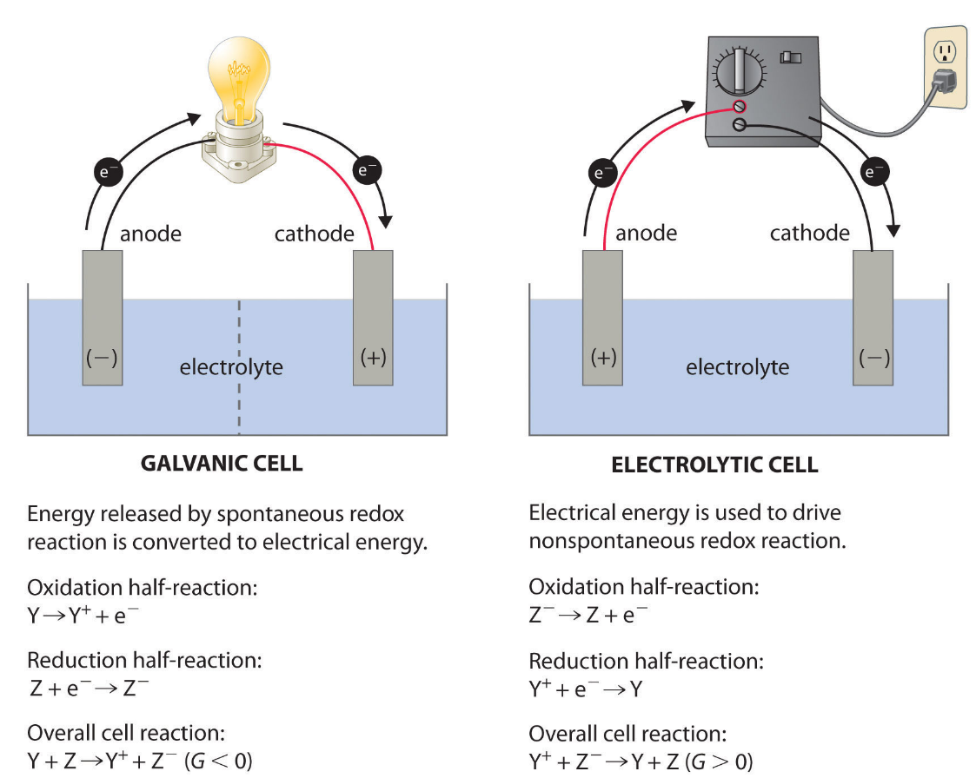
Electrochemical Cells. A galvanic cell (left) transforms the energy released by a spontaneous redox reaction into electrical energy that can be used to perform work. The oxidative and reductive half-reactions usually occur in separate compartments that are connected by an external electrical circuit; in addition, a second connection that allows ions to flow between the compartments (shown here as a vertical dashed line to represent a porous barrier) is necessary to maintain electrical neutrality. The potential difference between the electrodes (voltage) causes electrons to flow from the reductant to the oxidant through the external circuit, generating an electric current. In an electrolytic cell (right), an external source of electrical energy is used to generate a potential difference between the electrodes that forces electrons to flow, driving a nonspontaneous redox reaction; only a single compartment is employed in most applications. In both kinds of electrochemical cells, the anode is the electrode at which the oxidation half-reaction occurs, and the cathode is the electrode at which the reduction half-reaction occurs.

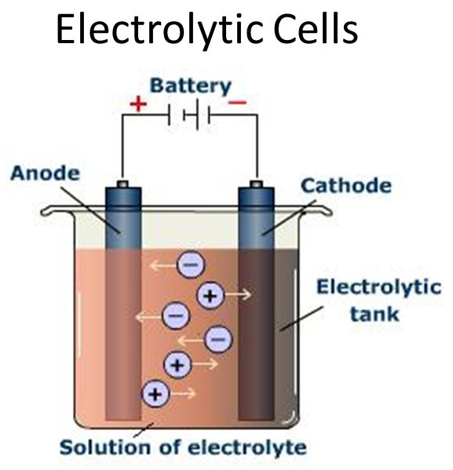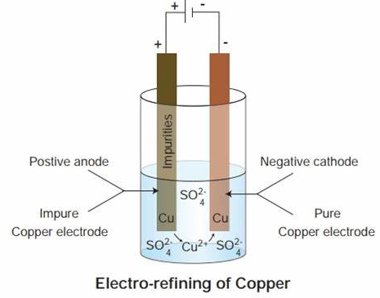
To explain what happens in an electrolytic cell let us examine the decomposition of molten sodium chloride into sodium metal and chlorine gas. The reaction is written below.
---------> Non spontaneous ( electrolytic cell )
2 Na Cl (l) | ⇌⇌ | 2 Na (s) | + | Cl₂ (g)
<--------- Spontaneous ( electrochemical cell )
If molten NaCl(l)NaCl(l) is placed into the container and inert electrodes of C(s)C(s) are inserted, attached to the positive and negative terminals of a battery, an electrolytic reaction will occur.
- Electrons from the negative terminal travel to the cathode and are used to reduce sodium ions into sodium atoms. The sodium will plate onto the cathode as it forms. The sodium ion are migrating towards the cathode.
Na++e−⇌Na(s)(2)(2)Na++e−⇌Na(s)
- The negative Chlorine ions migrate towards the anode and release electrons as they oxidize to form chlorine atoms. The chlorine atoms will combine together to form chlorine gas which will bubble away.
2Cl−⇌Cl2(g)+2e−(3)(3)2Cl−⇌Cl2(g)+2e−
- Note that the site of oxidation is still the anode and the site of reduction is still the cathode, but the charge on these two electrodes are reversed. Anode is now positive charged and the cathode has a negative charged.
- The conditions under which the electrolyte cell operates are very important. The substance that is the strongest reducing agent (the substance with the highest standard cell potential value in the table) will undergo oxidation. The substance that is the strongest oxidizing agent will be reduced. If an aqueous solution of sodium chloride were used in the above system, hydrogen would undergo reduction instead of sodium, because it is a stronger oxidizing agent that sodium.

